# CSV檔案匯入

**問題概述:**

**這次有特殊需求是要將A系統匯出的CSV檔讀出並匯入到B系統歸檔，之前對CSV檔很陌生，也沒操作過，操作過程中遇到不少的問題，所以在這邊做個紀錄。**

**CSV:**

CSV檔是一種純文字格式，中間以逗點隔開，可以使用記事本或是excel打開，

若是以excel開啟就像一般的xls檔一樣，用格子來取代文字檔中的逗點，讓檔案

的可讀性增加，但是要特別注意，用excel打開csv後再儲存.csv，可能會造成某

些內容被改變，要特別小心。

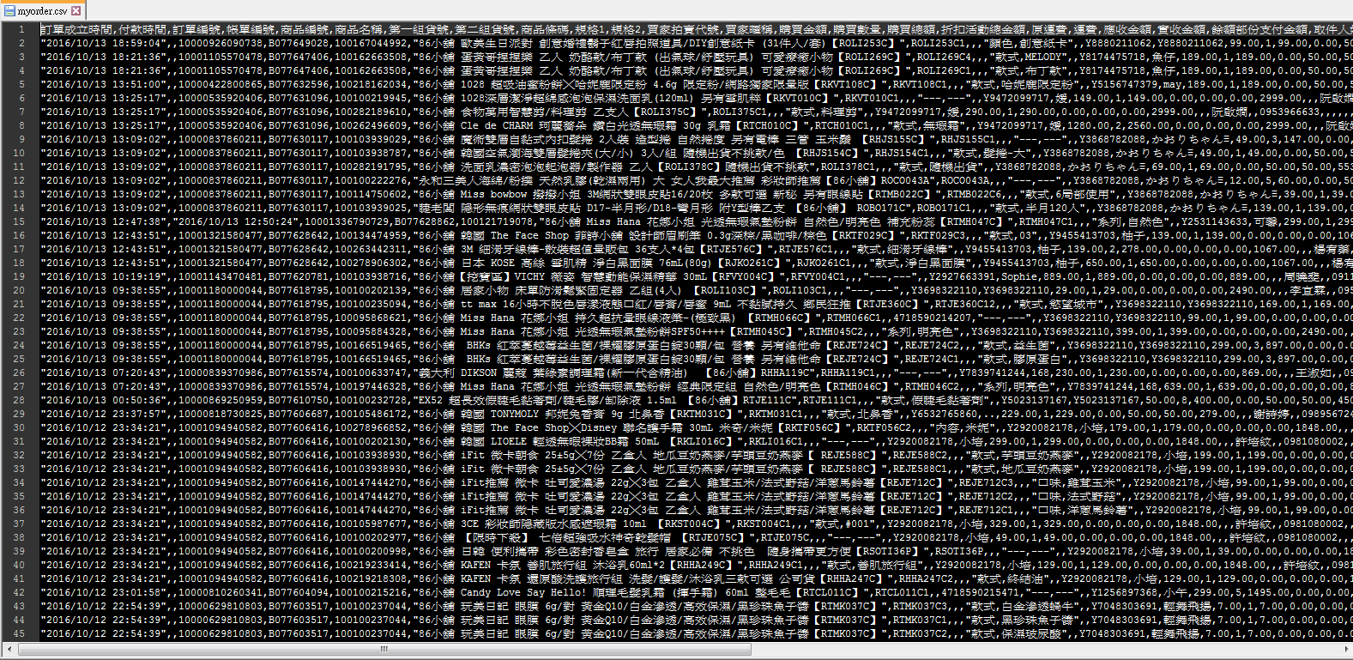

**CSV匯入:**

在後端接收到HttpPostedFileBase files後(files為CSV檔)

Csv檔驗證

String file711Extension = (files != null) ? System.IO.Path.GetExtension(files.FileName).ToLower() : ""; //取得上傳的檔案類型

if ((file711Extension != "" && file711Extension != ".csv" && file711Extension != ""))

{

msg += "請上傳CSV檔";

TempData["error_message"] = msg;

return View("Index");

}

//CSV檔案由UTF8轉BIG5 在儲存

byte[] fileContents = null;

Stream fileStream = files.InputStream;

var mStreamer = new MemoryStream();

mStreamer.SetLength(fileStream.Length);

fileStream.Read(mStreamer.GetBuffer(), 0, (int)fileStream.Length);

mStreamer.Seek(0, SeekOrigin.Begin);

fileContents = mStreamer.GetBuffer();

string origString = System.Text.Encoding.UTF8.GetString(fileContents, 0, fileContents.Length);

string result = Encoding.GetEncoding(950).GetString(Encoding.Convert(Encoding.Unicode, Encoding.GetEncoding(950), Encoding.Unicode.GetBytes(origString)));

var path = Path.Combine(Server.MapPath("~/FileUploads"), rnd.Next() + Path.GetFileName(files.FileName));

System.IO.File.WriteAllText(path, result, Encoding.GetEncoding(950));

//開始處理資料file

ExcelQueryFactory excelFile = new ExcelQueryFactory(path);

string[] my_cls = {

"?訂單成立時間",

"付款時間",

"訂單編號",

"帳單編號",

}

//驗證欄位

using (StreamReader reader = new StreamReader(path, System.Text.Encoding.GetEncoding(950)))

{

string line = reader.ReadLine();

if (line != "")

{

string[] excel_cls = line.Replace("\"", string.Empty).Split(new char[] { ',' }, StringSplitOptions.None);

string[] notin = (from C in my_cls where !excel_cls.Contains(C) select C).ToArray();

if (notin.Count() > 0)

{

msg += "您所上傳的『拍賣格式』缺少以下欄位：" + String.Join("；", notin);

TempData["error_message"] = msg;

return View("Index");

}

}

}

//Mapping

excelFile.AddMapping<ToKantOrderYahooBidView>(p => p.A01, "?訂單成立時間");

excelFile.AddMapping<ToKantOrderYahooBidView>(p => p.A02, "付款時間");

excelFile.AddMapping<ToKantOrderYahooBidView>(p => p.A03, "訂單編號");

excelFile.AddMapping<ToKantOrderYahooBidView>(p => p.A04, "帳單編號");

excelFile.AddMapping<ToKantOrderYahooBidView>(p => p.A05, "商品編號");

var excelData = excelFile.Worksheet<ToKantOrderYahooBidView>(0);

//「訂單狀態」=有效 才可以寫入，要排除"已取消"

myList1 = excelData.Where(x => x.A36 == "有效").ToList();